Luttrell, Steve (from Workskills website)
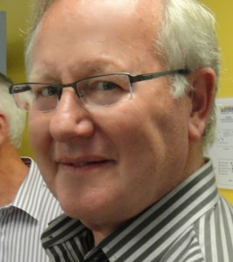
Born & raised in Hobart, Steve completed a Bachelor of Science (Forestry) at Australian National University. Steve returned to Tasmania and worked with Forestry Commission/Forestry Tasmania including in senior management positions in operational management and sales/marketing. He also gained experience in private enterprise through secondment and then project work subsequent to retirement. Steve has been a Board member of Workskills for 5 years and is also a director of the Forest Practices Authority.

